

1

 | FINAL ASSIGNEMNT
Student Name:  Section Number: | Sara Mehrem Course Name: Secure Coding  Section 1 Instructor Name: Dr. Safaa Hriez

Contents
Security Principles 3
Fail Securely Principle 3
Secrets Are Not Kept Principle 3
Quality Principles 4
Testability Principle 4
Readability Principle 4
Use Case and Misuse Case Diagrams 5
Tabular Description of Use Case and misuse case 6
Data Flow Diagrams 8
Context Diagram 8
Level 0 Diagram 9
Level 1 Diagram 10
Quality Testing 11
Unit Testing 11
Test case 11
Unit testing implementation 12
Integration Testing 14
Security Testing 15
Dynamic Testing 15
Fuzz Testing 15
Static Testing 18
Static code analysis 18
Code Versioning 19

Security Principles
There are many security principles that are used in the HealthClinicPro application, such as,

Fail Securely Principle
Fail securely principle considers very important concept in terms of the design and implementation of secure application. Which is that the system should deal and handle the exceptions, failures, and errors in a secure approach/strategy, ensuring that even the application fails, the application doesn’t detect the vulnerabilities or provide a chance for exploitation.

I apply fail securely principle in HealthClinicPro application by exception handling.
There are many benefits for fail securely principle, such as,
- Enhance security in general
- Reduce the chances for exploitation
- Mitigate the risks
- Protect critical data
- Maintain the integrity of the application
- And so on

Secrets Are Not Kept Principle
Secrets are not kept principle indicates to that the secrets (such as, username and password) should be not written in the code as is, because the attacker may see the code (even it is a binary code, it can be retrieved to the original code) and exploit the secrets. So, the secrets should be retrieved from database or files.

I apply secrets are not kept in HealthClinicPro application by retrieving the secrets from files.
There are many benefits for secrets are not kept principle, such as,
- Hide the secrets from the code, so reduce the exploitation
- Protect critical data
- Compliance with security standards
- Enhance security
- Reduce the risks and data breaches
- And so on

Quality Principles

There are many quality principles that are used in the HealthClinicPro application, such as,

Testability Principle
Testability quality principle indicates to the degree of which the system can be efficiently tested. This quality principle is very important because it effects the eases of discovers and corrects the defects.

This principle is applied in the HealthClinicPro code, so I tested it in more than one way efficiently and effectively. In terms of quality testing, I used unit testing and integration testing. Also, in terms of security testing, I used fuzzing testing and static cod analysis.
There are many benefits of testability principle such as,
- Identify the defects efficiently
- Improve the code quality
- Reduce testing time and costs
- Enhance the debugging
- Better maintainability
- And so on

Readability Principle
Readability quality principle in software design and development indicates to ensuring that the code is readable (the code is written in readable syntax and style) by human. This principle is very important because usually the application is maintained by developers other than the authors. Also, it supports the collaboration between developers.

There are many benefits of readability principle such as,
- Improve the application maintainability
- Enhance the collaboration between developers
- Improve the code quality
- Facilitate code reviews
- Enhance the errors tracing
- And so on

Use Case and Misuse Case Diagrams

Below, the use case and misuse case diagram for the HealthClinicPro application.

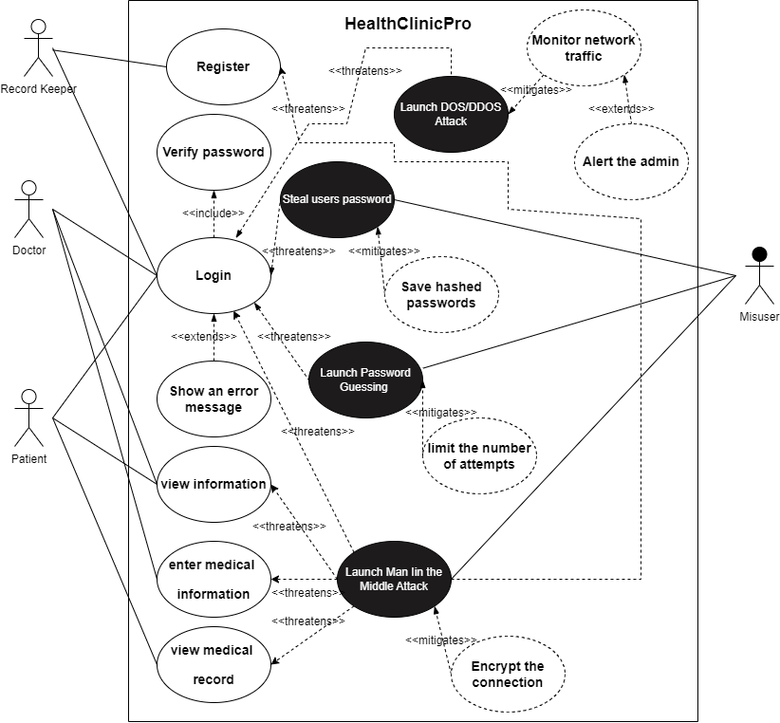

Tabular Description of Use Case and misuse case
Below the tabular description for the use case and misuse case of the HealthClinicPro.
Use case name | Register | Use case number | 1
Primary actors | Record Keeper | Secondary actors | None
Description | Allow the record keeper to register doctors and patients in the system  (creating accounts for new doctors and patients)
Pre-condition | Record keeper has a valid account
Post-condition | The system contains new account for doctor or patient
Main flow | Write doctor or patient information  Show a successful message  The system contains new doctor or patient account
Alternative flow | None

Use case name | Login | Use case number | 2
Primary actors | Record Keeper, Doctor, Patient | Secondary actors | None
Description | Allow Record Keeper/Doctor/Patient to login in his/her account
Pre-condition | Record Keeper/Doctor/Patient has a valid account
Post-condition | The system displays the suitable home page
Main flow | Record Keeper/Doctor/Patient enters his/her username and password  The system triggers verify password use case  The system displays the suitable home page
Alternative flow | 2.a. invalid username and password  1. The system triggers show an error message use case  2. The systems prompts for the user name and password  3. The use case resumes at main flow step 1  2.b. maximum 3 attempts exceeded  1. The system displays a message that the user exceeds the limit  2. The system locks the user account  3. The user case ends

Use case name | View information | Use case number | 3
Primary actors | Doctor, Patient | Secondary actors | None
Description | Allow doctor/patient to view his/her information
Pre-condition | Doctor/Patient has a valid account
Post-condition | The system displays doctor/patient information
Main flow | Choose (1. To view my information) from the menu  The system displays the required information
Alternative flow | None

Use case name | Enter medical information | Use case number | 4
Primary actors | Doctor | Secondary actors | None
Description | Allow the doctor to enter the medical information for the patient
Pre-condition | Doctor has a valid account
Post-condition | The system saves the medical information for the patient
Main flow | Choose (2. To enter medical information) from the menu  Write the patient name and medical information  Show an added successfully message  The system saves the medical information for the patient
Alternative flow | None

Use case name | View medical record | Use case number | 5
Primary actors | Patient | Secondary actors | None
Description | Allow the patient to view his/her medical information
Pre-condition | Patient has a valid account
Post-condition | The system displays the medical information for the patient
Main flow | Choose (2. To view my medical information) from the menu  The system displays the medical information for the patient
Alternative flow | None

Data Flow Diagrams

Below, the data flow diagrams for the applications includes, context diagram, level 0 diagram, and level 1 diagram.

Context Diagram
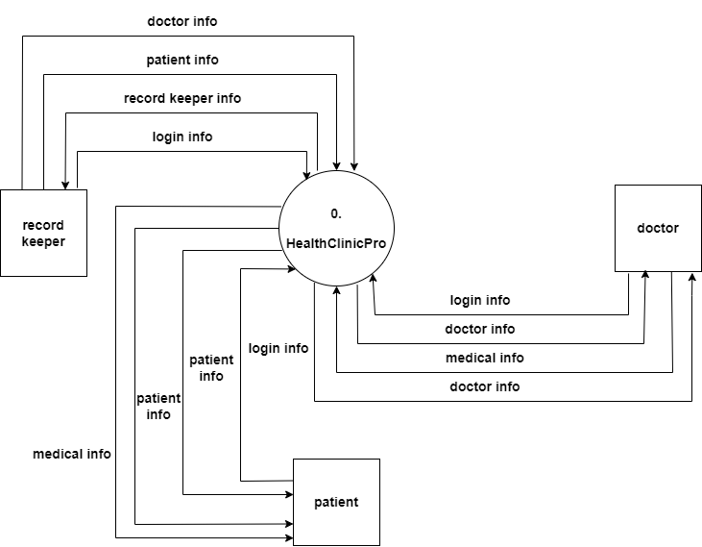

Level 0 Diagram
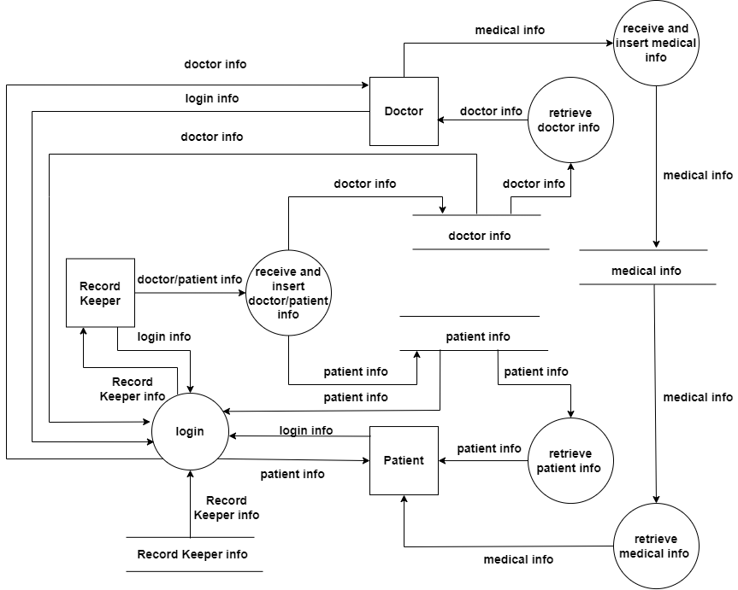

Level 1 Diagram
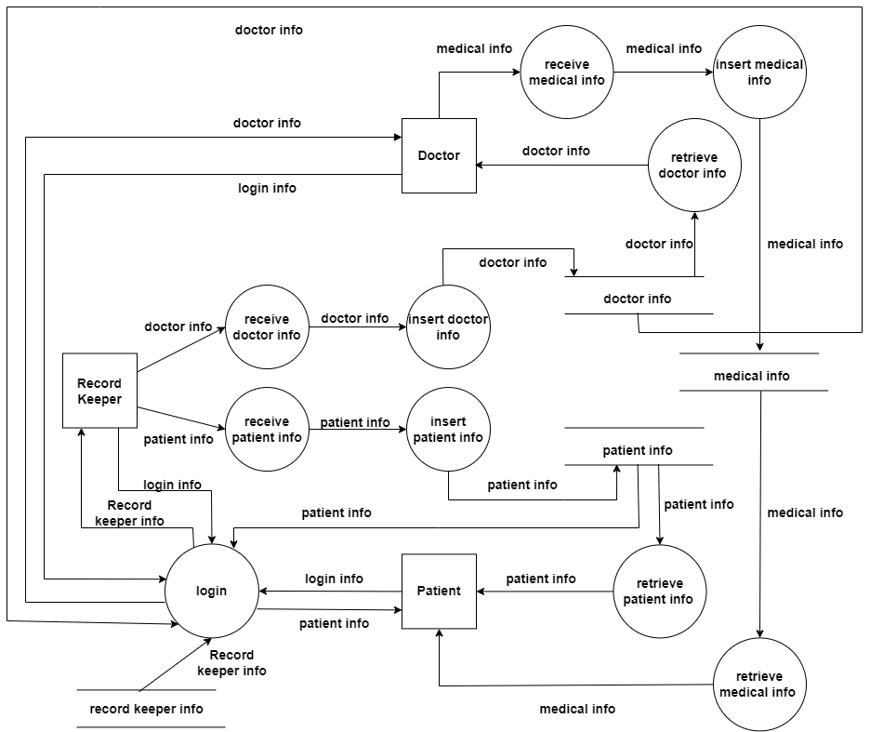

Quality Testing

Quality testing indicates to test the application in terms of quality. Which is a process to evaluate the application product for ensuring that meets the required quality and ensuring that the application works as expected.
There are many benefits for the quality testing, such as,
- Improve the application's performance and make it reliable
- Enhance the user satisfaction
- Cost effective
- Enhance the quality in general
- And so on

Unit Testing
I used unit testing which a functional testing to test the quality using Junit tool. Unit testing is a quality testing technique which is test the units by test each unit in isolation from the rest of the system for ensuring its reliability and correctness. The unit indicates to a piece of code to test such as, function, method, or maybe class. The aim of unit testing, validates that each unit of the application works correctly as the required.
There are many benefits of unit testing such as,
- Detect the bugs
- Improve the code quality
- Enhance the collaboration
- Isolate the issues
- Comprehensive test coverage
- And so on

Test case
Test Case for, recordKeeperLogin Function, doctorLogin Function, patientLogin Function, and regex Function

ID | What to test | Description (input) | Expected | Actual | Status
1 | recordKeeperLogin Function | Sara,21110331Ss | True | True | Pass
2 | recordKeeperLogin Function | sara,21110331Ss | False | False | Pass
3 | recordKeeperLogin Function | Sara,1110331Ss | False | False | Pass
4 | recordKeeperLogin Function | sara,1110331Ss | False | False | Pass
5 | recordKeeperLogin Function | empty,21110331Ss | False | False | Pass
6 | recordKeeperLogin Function | Sara,empty | False | False | Pass
7 | recordKeeperLogin Function | empty,empty | False | False | Pass
8 | doctorLogin Function | ali,12345678Aa | True | True | Pass
9 | doctorLogin Function | Ali,12345678Aa | False | False | Pass
10 | doctorLogin Function | ali,12345678 | False | False | Pass
11 | doctorLogin Function | Ali,12345678 | False | False | Pass
12 | doctorLogin Function | empty,12345678Aa | False | False | Pass
13 | doctorLogin Function | ali,empty | False | False | Pass
14 | doctorLogin Function | empty,empty | False | False | Pass
15 | patientLogin Function | ahmad,Aa87654321 | True | True | Pass
16 | patientLogin Function | Ahmd,Aa87654321 | False | False | Pass
17 | patientLogin Function | ahmad,87654321 | False | False | Pass
18 | patientLogin Function | Ahmad,A87654321 | False | False | Pass
19 | patientLogin Function | empty,Aa87654321 | False | False | Pass
20 | patientLogin Function | ahmad,empty | False | False | Pass
21 | patientLogin Function | empty,empty | False | False | Pass
22 | regex Function | 21110331Ss | True | True | Pass
23 | regex Function | 21110331Ss& | True | True | Pass
24 | regex Function | 21110331 | False | False | Pass
25 | regex Function | 21110331S | False | False | Pass
26 | regex Function | 21110331s | False | False | Pass
27 | regex Function | SSSS | False | False | Pass
28 | regex Function | ssss | False | False | Pass
29 | regex Function | &&&& | False | False | Pass
30 | regex Function | 21110331& | False | False | Pass
31 | regex Function | 21110331S& | False | False | Pass
32 | regex Function | 21110331s& | False | False | Pass
33 | regex Function | SSSS& | False | False | Pass
34 | regex Function | ssss& | False | False | Pass
35 | regex Function | Ss& | False | False | Pass
36 | regex Function | empty | False | False | Pass

Unit testing implementation
Function | Screenshot of the unit testing using Junit tool
recordKeeperLogin Function | 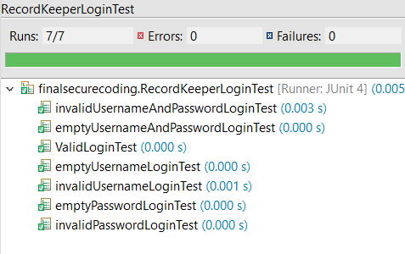
doctorLogin Function | 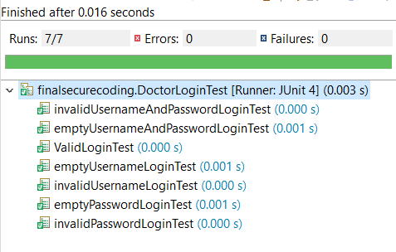
patientLogin Function | 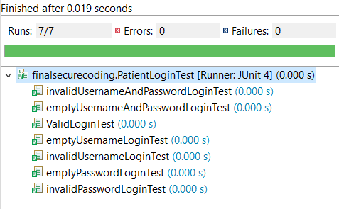
regex Function | 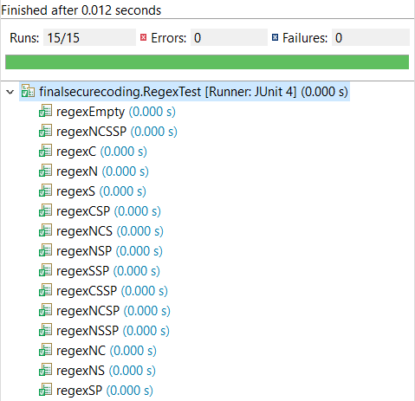
Test all | 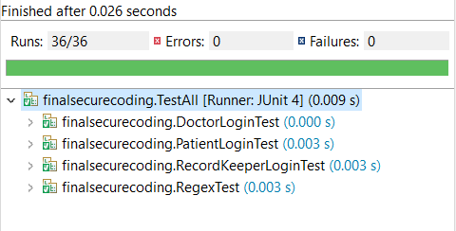

Integration Testing
It is a quality testing and functional testing, this type merges software units logically (feature at a time) and tests the integrity between them as a group. I did this testing manually for the menu of HealthClinicPro, login for record keeper, menu of record keeper, and register doctor function.
There are many benefits for integration testing, such as,
- Ensure the integration of components
- Detect the issues early
- Improve the quality
- Reduce the risks of application failure
- And so on

Below is the result of integration testing to, menu of HealthClinicPro, login for record keeper, menu of record keeper, and register doctor function.

Point | Screenshot
1 | 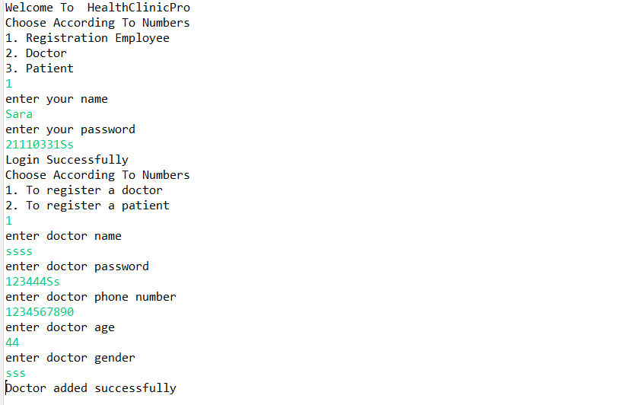

Security Testing

Security testing is a technique or process for identifying the vulnerabilities in the application to protect it from the threats and potential attacks. It aims to ensure that the application is secure in terms different types of cyber threats. Also, it is very important because it plays crucial role to ensure C.I.A.
There are many benefits of security testing, such as,
- Identify and mitigate vulnerabilities
- Protect from attacks
- Compliance to the regulation
- And so on

Dynamic Testing
Dynamic testing in security testing indicates to the process or technique of evaluate the application by executing it and monitor its behavior in real time for identifying the potential vulnerabilities. Dynamic testing includes interacting with the application within it is under running.
There are many benefits of dynamic testing such as,
- Detect runtime errors
- Real world usage simulation
- Evaluate the application's performance
- And so on

Fuzz Testing
I used a FUZZ testing (fuzzing), which is a technique involves provide a random data as an input to the application for monitoring its behavior and seeing what happens to the results. FUZZ testing aims to discover the weaknesses/vulnerabilities and crashes, or discover the unexpected behavior of the application, consider the run time errors and buffer overflow. This technique helps to identify the security vulnerabilities.
There are many benefits of FUZZ testing such as,
- Discover the security vulnerabilities
- Cost effectiveness
- Detection of issues
- Comprehensive testing
- Adaptability to different software types
- And so on

Also, I used jazzer tool for security testing to test recordKeeperLogin and regex functions.

regex function
Point | Screenshot
1 | 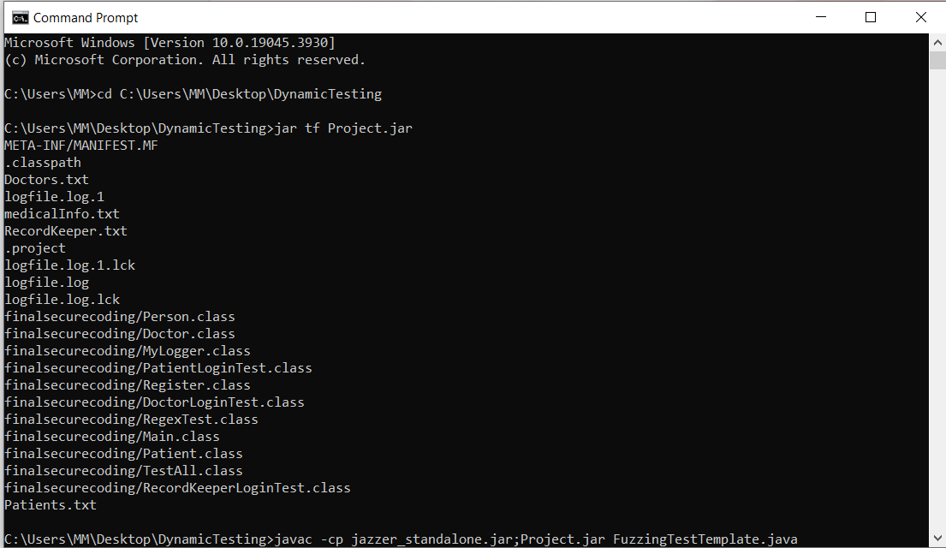
2 | 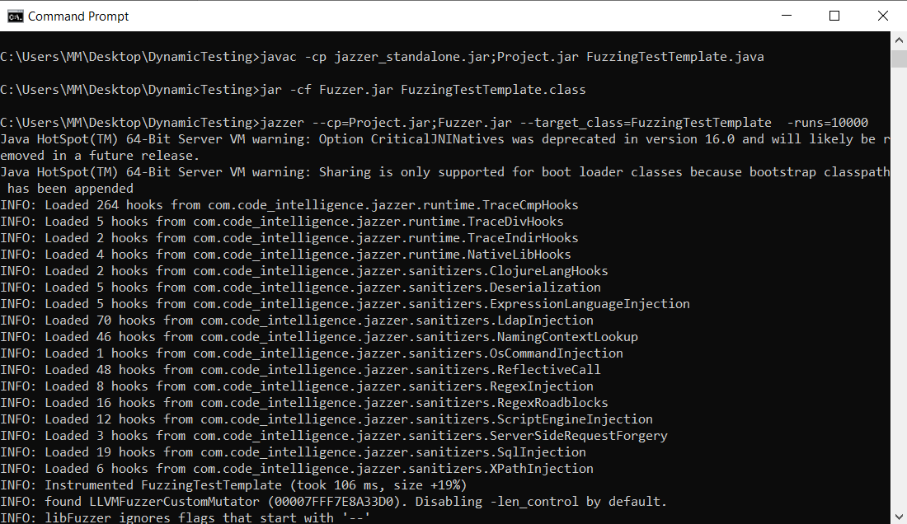
3 | 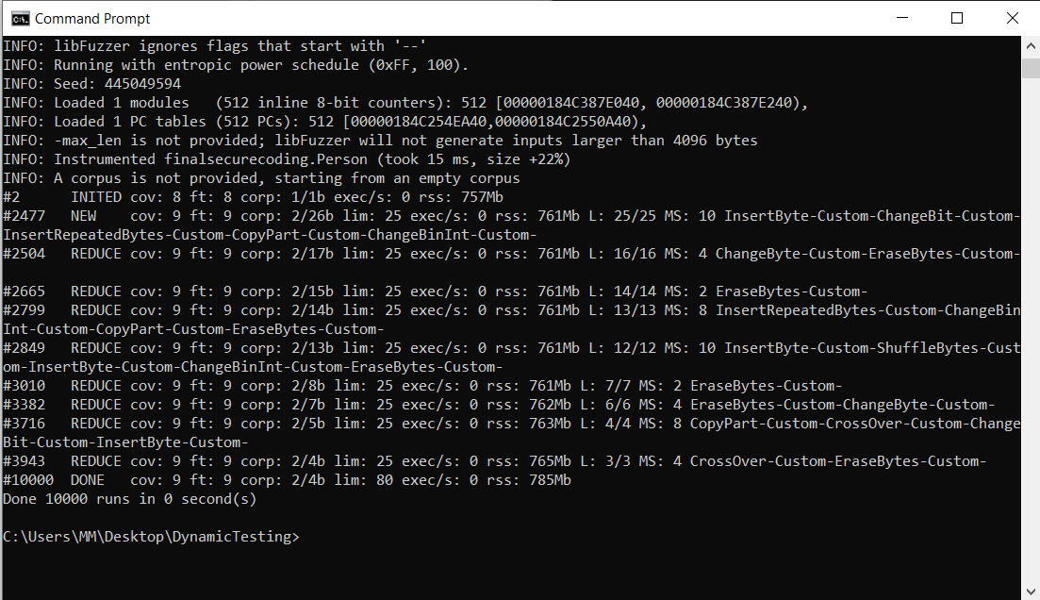

recordKeeperLogin function
point | Screenshot
1 | 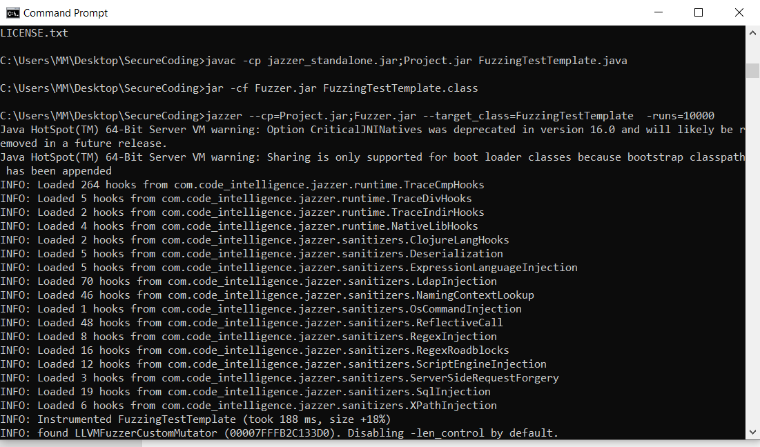
2 | 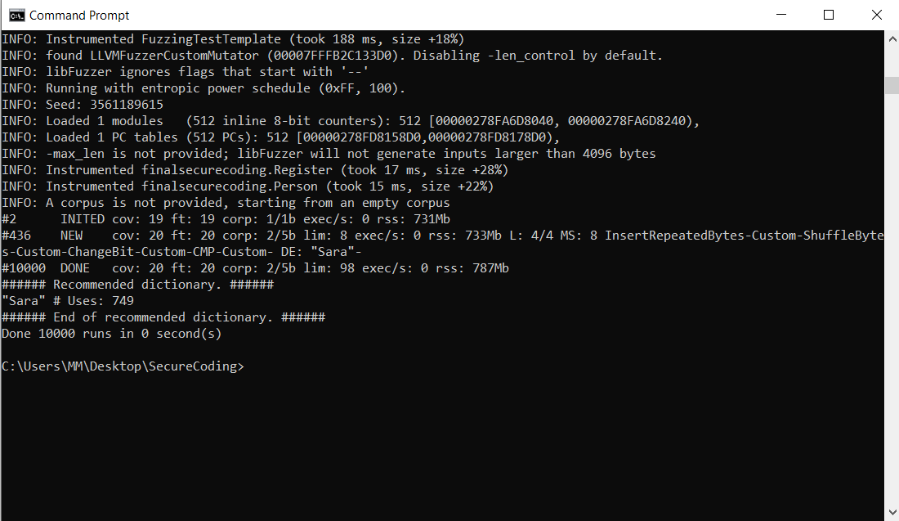

Static Testing
Static testing in security testing indicates to the process of examining or analyzing the source code (instructions) of the application without running to identify the security vulnerabilities. It helps to detect the issues early in SDLC.
There are many benefits of static testing, such as,
- Early detect errors
- Identify the security vulnerabilities
- Review process efficiently
- Effective in terms of cost
- And so on

Static code analysis
It is an approach used in application development which is by examining and analyzing the code without running the application, in this approach is done using tools. (I used PMD tool for it). It aims to find the errors, bugs, and potential vulnerabilities in the code.
There are many benefits for the static code analysis, such as,
- Detect the bugs early
- Detect the potential vulnerabilities
- Automated code review
- Save the time and resources
- Mitigate the risks
- And so on

Point | Command
1 | cd C:\Users\MM\Desktop\StaticTesting\pmd-bin-7.0.0-rc4\bin
2 | pmd.bat check -f csv -R rulesets/java/quickstart.xml --dir C:\Users\MM\Desktop\StaticTesting\finalsecurecoding –r C:\Users\MM\Desktop\StaticTesting\output.csv

Code Versioning

Cod versioning for HealthClincPro code using Git Bash tool
github link: SecureCodingProject/finalsecurecoding at main · SaraMehrem/SecureCodingProject (github.com)

Point | Screenshot
1 | 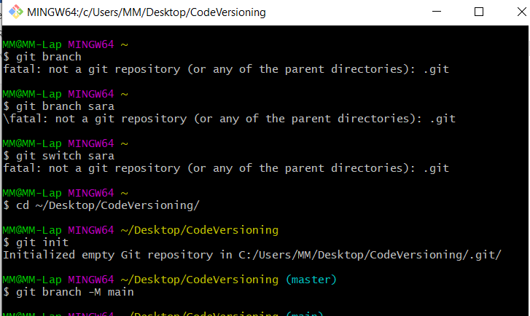
2 | 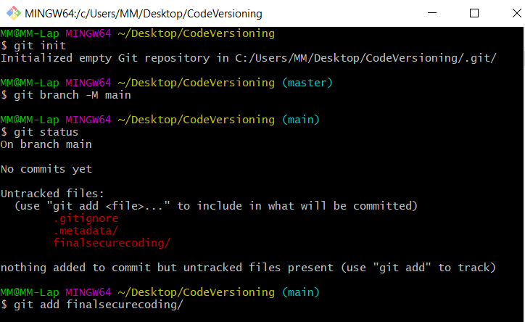
3 | 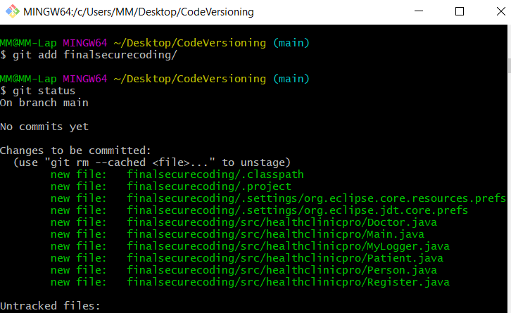
4 | 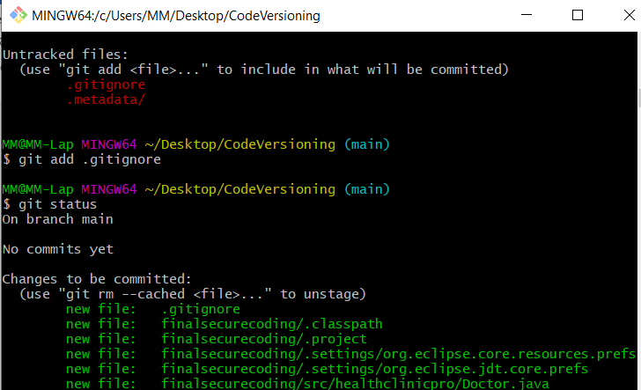
5 | 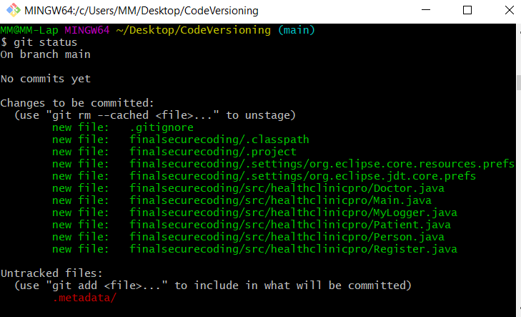
6 | 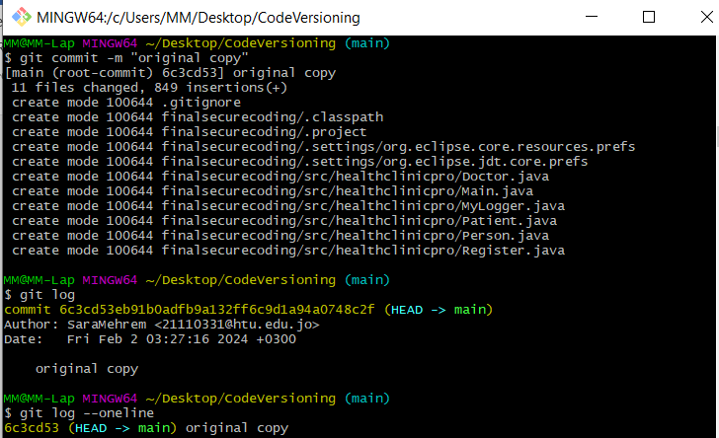
7 | 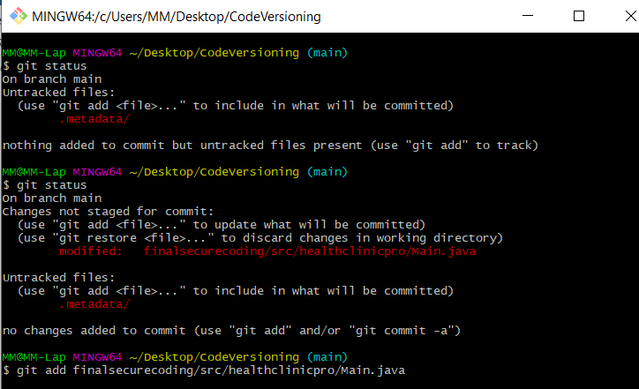
8 | 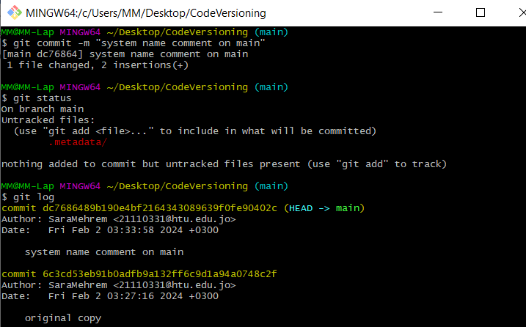
9 | 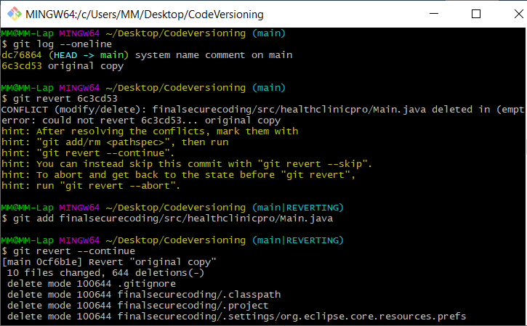
10 | 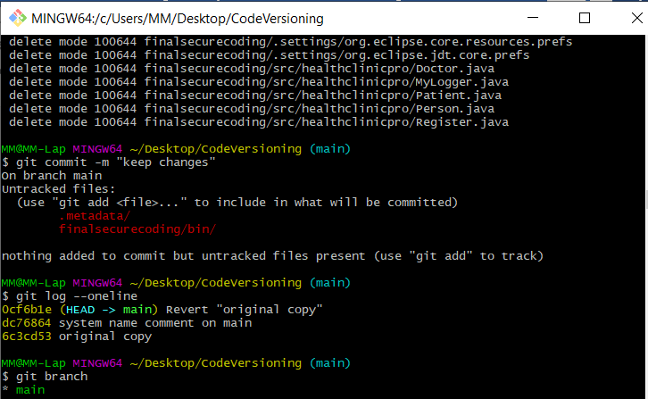
11 | 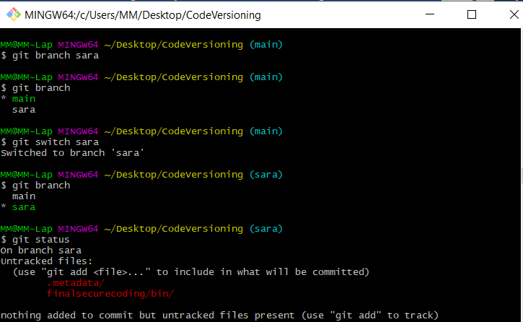
12 | 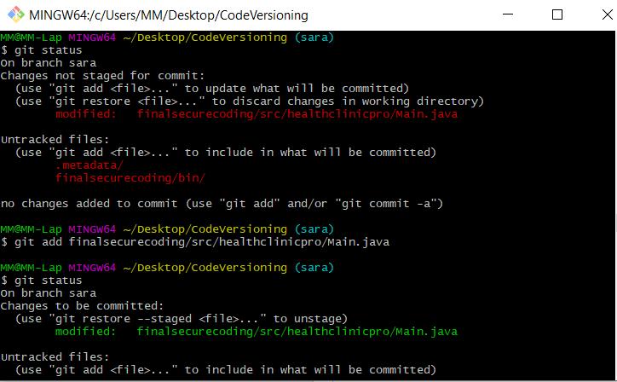
13 | 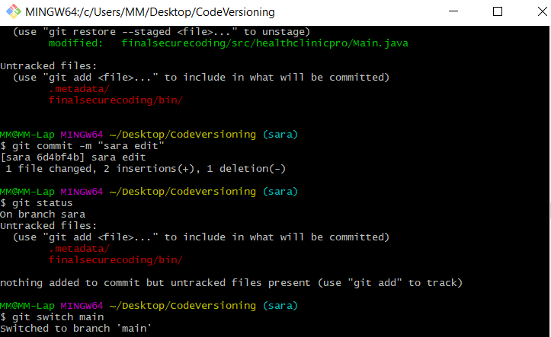
14 | 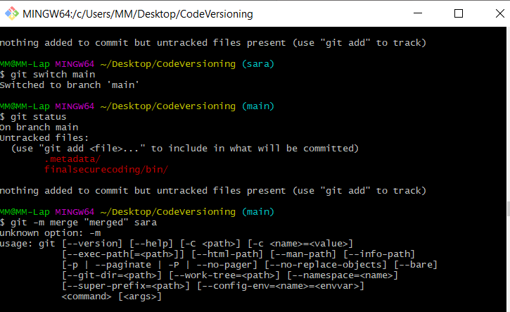
15 | 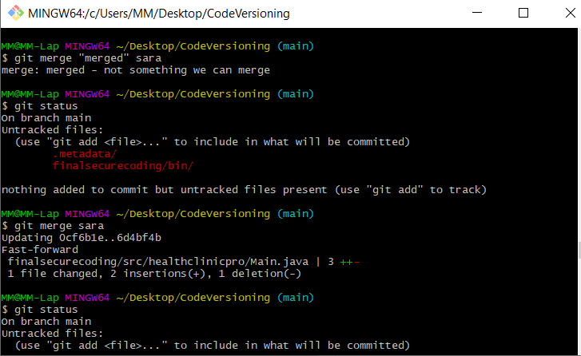
16 | 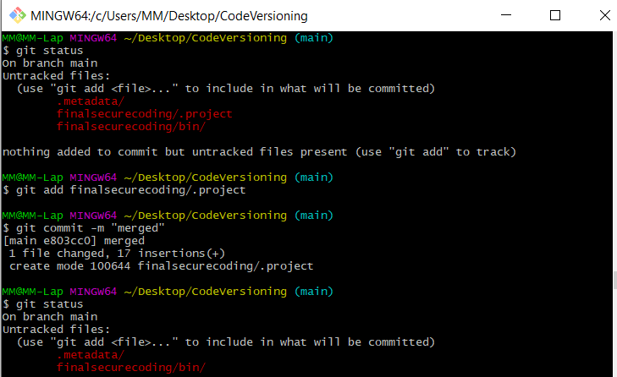
17 | 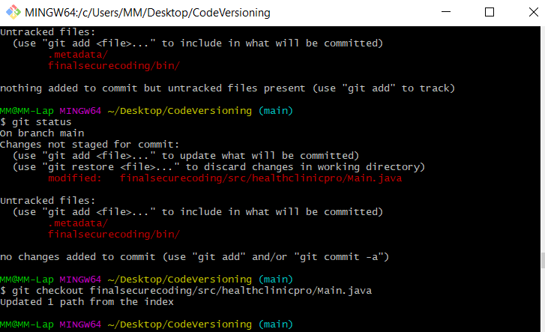
18 | 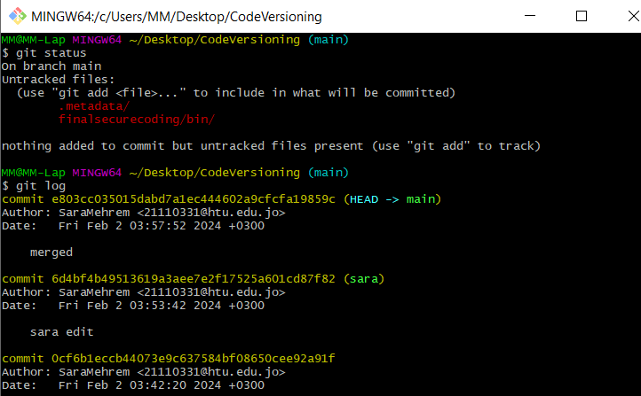
19 | 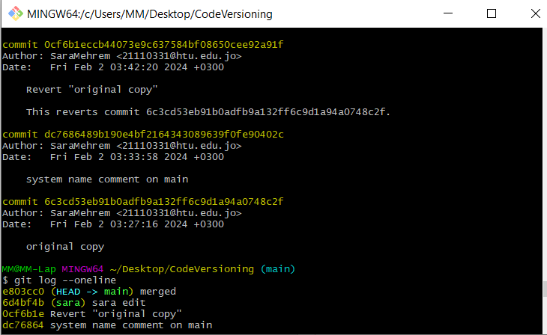
20 | 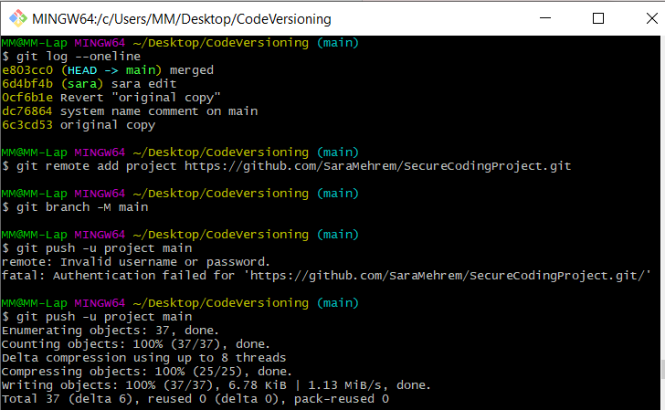
21 | 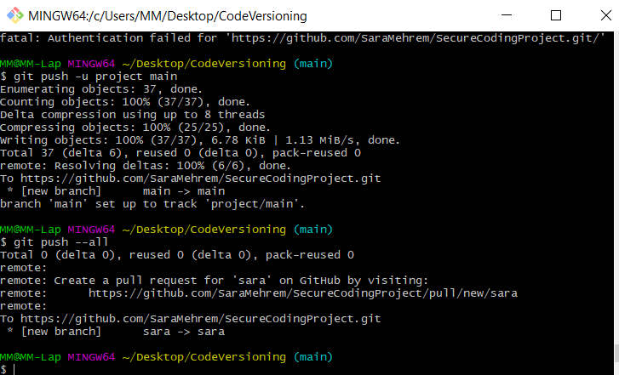
22 | 